Immigration and Refugee Crises – What’s a Catholic to Think?
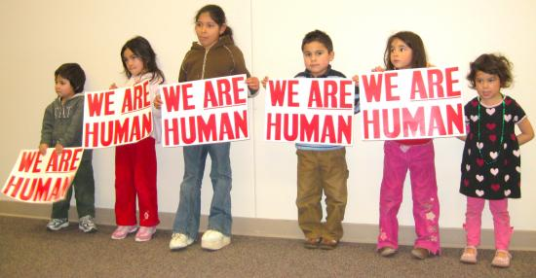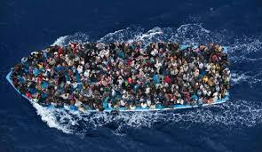
Part I: A Defining Issue for Catholics
Americans are divided on many issues, but none more than how to respond to the recent crises of undocumented immigrants on our southern border and huge numbers of refugees from the Middle East. Many believe we need to build higher walls, deport more people, and stop accepting Muslim refugees, in order to save jobs or protect us from terrorism. But the Church has been emphatic that we instead take our cue from the scriptural command to “welcome the stranger” and the Gospel appeal to “let love drive out fear.”
Pope Francis said in 2014 that “The Church opens her arms to welcome all people, without distinction or limits, in order to proclaim that 'God is love'.” Our United States Bishops, while recognizing the right of nations to safeguard their borders, also insist that “families have the right to migrate for economic opportunities, for freedom, or for safety,” and that “as an obligation of justice and mercy, nations who can receive immigrants without detriment to the welfare of their citizens should do so.”
So we cannot give in to simplistic calls to “keep them out.” We must oppose draconian responses that would treat all undocumented persons as dangerous, tear apart families, or deny basic human rights. Future installments in this series will provide more background on the causes of migration and address frequently-asked questions about refugees and undocumented migrants. But first, a word about something even more basic, a question many Catholics ask...
Shouldn’t the Church Stay Out of Politics?
Yes… if by politics you mean partisan campaigning, endorsing candidates or parties, or other violations of its non-profit status, the Church has specific guidelines against such activities.
But, if by politics you mean weighing in on the moral dimension of political issues and debates, then by all means NO! Catholic social teaching is very clear on this point.
"'A good Catholic doesn't meddle in politics.' That's not true.… None of us can say, 'I have nothing to do with this, they govern. No, no, I am responsible for their governance, and I have to do the best so that they govern well, and I have to do my best by participating in politics according to my ability. Politics, according to the Social Doctrine of the Church, is one of the highest forms of charity, because it serves the common good. I cannot wash my hands, eh?”
Pope Francis, Sept. 26, 2013 Homily
Vatican II quotes St. Thomas More: “man cannot be separated from God, nor politics from morality.” Pope Paul VI wrote of political involvement as “a Christian duty.” And the US Conference of Catholic Bishops (USCCB) has said: “the separation of church and state does not require division between belief and public action, between moral principles and political choices, but protects the right of believers and religious groups to practice their faith and act on their values in public life." The Catechism of the Catholic Church adds: “Because of the public relevance of the Gospel and faith, because of the corrupting effects of injustice, that is, of sin, the Church cannot remain indifferent to social matters. To the Church belongs the right always and everywhere to announce moral principles, including those pertaining to the social order, and to make judgments on any human affairs to the extent that they are required by the fundamental rights of the human person or the salvation of souls.”
The Bible on Welcoming Strangers
“The LORD your God is the God of all gods and Lord of all lords, the great, mighty, and awesome God who doesn’t play favorites and doesn’t take bribes. He enacts justice for orphans and widows, and he loves immigrants, giving them food and clothing. That means you must also love immigrants because you were immigrants in Egypt” (Deuteronomy 10:17-19)
“You must not oppress foreigners. You know what it’s like to be a foreigner, for you yourselves were once foreigners in the land of Egypt” (Exodus 23:9)
“When a stranger sojourns with you in your land, you shall not do him wrong. You shall treat the stranger who sojourns with you as the native among you, and you shall love him as yourself, for you were strangers in the land of Egypt: I am the LORD your God” (Leviticus 19:33-34)
“The same law applies both to the native-born and to the foreigner residing among you” (Exodus 12:49)
“You have brought your judgment days near and have come to your years of punishment [because] father and mother are treated with contempt, and the foreign resident is exploited within you. The fatherless and widow are oppressed in you” (Ezekiel 22:4, 7)
“‘For I was hungry, and you gave Me something to eat; I was thirsty, and you gave Me something to drink; I was a stranger, and you invited Me in; naked, and you clothed Me; I was sick, and you visited Me; I was in prison, and you came to Me.’ Then the righteous will answer Him, ‘Lord, when did we see You hungry, and feed You, or thirsty, and give You something to drink? And when did we see You a stranger, and invite You in, or naked, and clothe You? When did we see You sick, or in prison, and come to You?’ The King will answer and say to them, ‘Truly I say to you, to the extent that you did it to one of these brothers of Mine, even the least of them, you did it to Me’” (Matthew 25:35-40)
Prepared by the Justice, Peace and Reconciliation Office, Priests of the Sacred Heart, U.S. Province
414-427-4273 • email: justdir@usprovince.org

